## **Module 1 Assignment: Web Basics**

Saurabh Kale

IFT 458/554: Middleware Programming & Database Security

Dinesh Sthapit

Aug 25th, 2023

* Node.js Installation and Visual Studio Code Installation

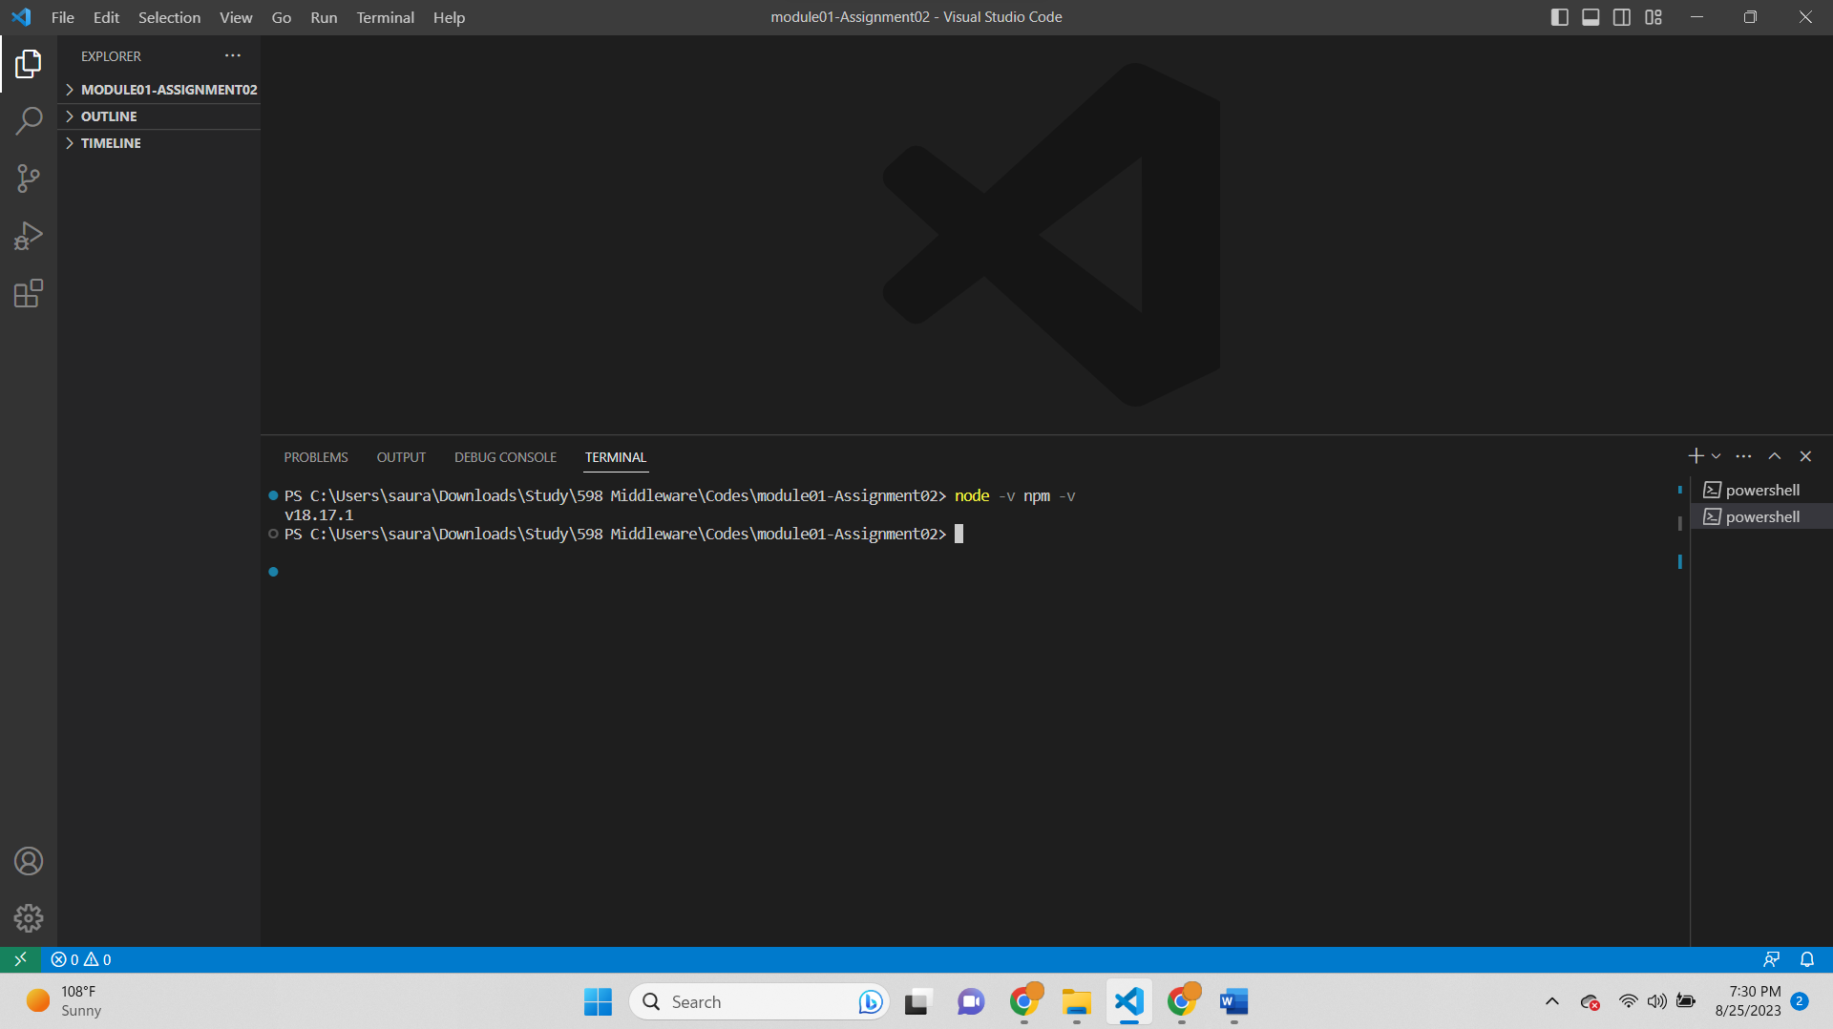

* Node Project Initialize

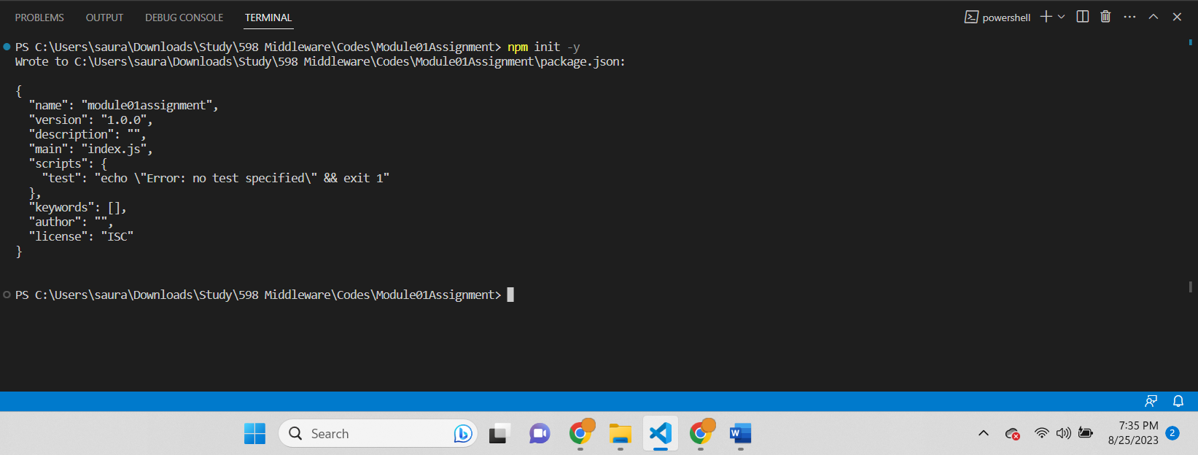

output-

Wrote to C:\Users\saura\Downloads\Study\598 Middleware\Codes\Module01Assignment\package.json:

{

"name": "module01assignment",

"version": "1.0.0",

"description": "",

"main": "index.js",

"scripts": {

"test": "echo \"Error: no test specified\" && exit 1"

},

"keywords": [],

"author": "",

"license": "ISC"

}

* Install Dependencies  
  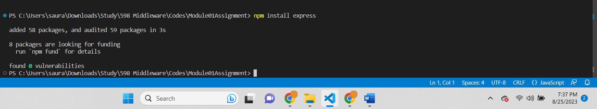

Output-  
added 58 packages, and audited 59 packages in 3s

8 packages are looking for funding

run `npm fund` for details

found 0 vulnerabilities

* Run the Node.js Project  
  A computer screen shot of a black screen

  Description automatically generated  
  Output-  
  Welcome to IFT 458
* **Basic Static Web Project Using Node.js and EJS**

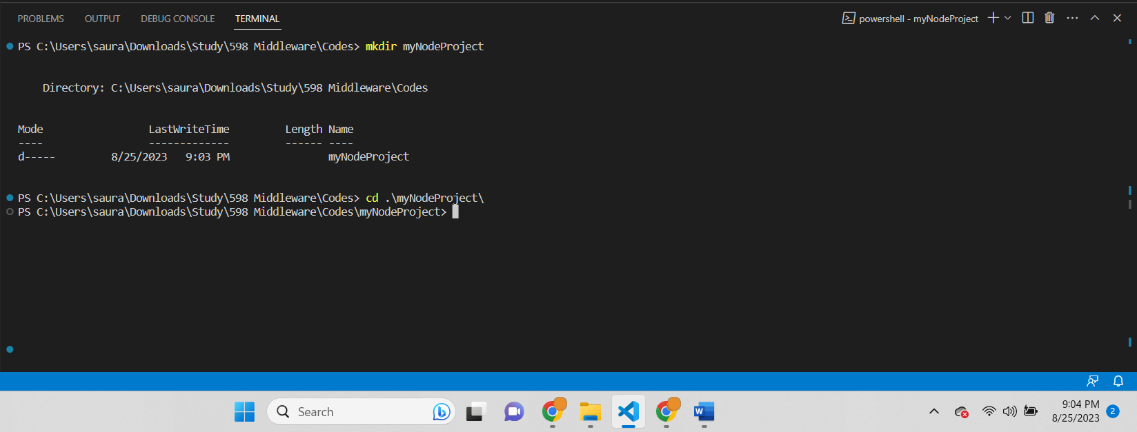

Created a project folder with ‘mkdir’ command and changed the directory to that folder using ‘cd’

Script-

PS C:\Users\saura\Downloads\Study\598 Middleware\Codes> mkdir myNodeProject

Directory: C:\Users\saura\Downloads\Study\598 Middleware\Codes

Mode LastWriteTime Length Name

---- ------------- ------ ----

d----- 8/25/2023 9:03 PM myNodeProject

PS C:\Users\saura\Downloads\Study\598 Middleware\Codes> cd .\myNodeProject\

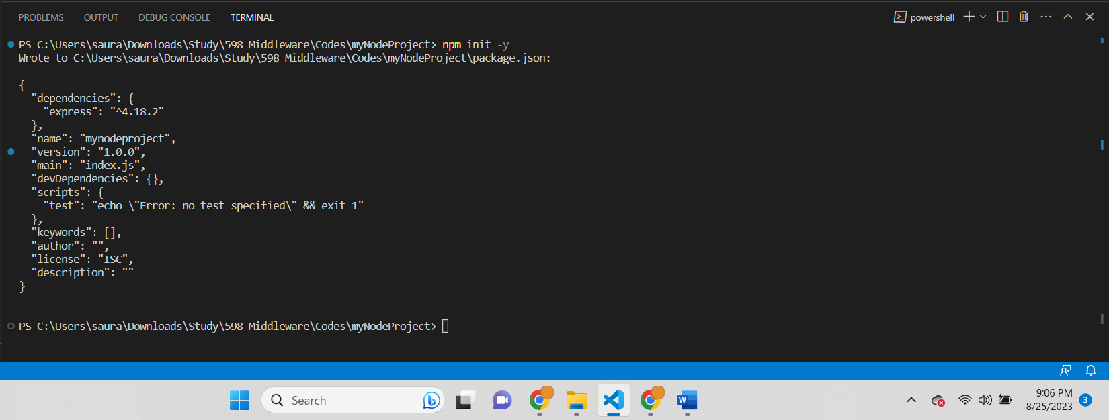

Node project initiated using npm init -y  
PS C:\Users\saura\Downloads\Study\598 Middleware\Codes\myNodeProject> npm init -y

Wrote to C:\Users\saura\Downloads\Study\598 Middleware\Codes\myNodeProject\package.json:

{

"dependencies": {

"express": "^4.18.2"

},

"name": "mynodeproject",

"version": "1.0.0",

"main": "index.js",

"devDependencies": {},

"scripts": {

"test": "echo \"Error: no test specified\" && exit 1"

},

"keywords": [],

"author": "",

"license": "ISC",

"description": ""

}

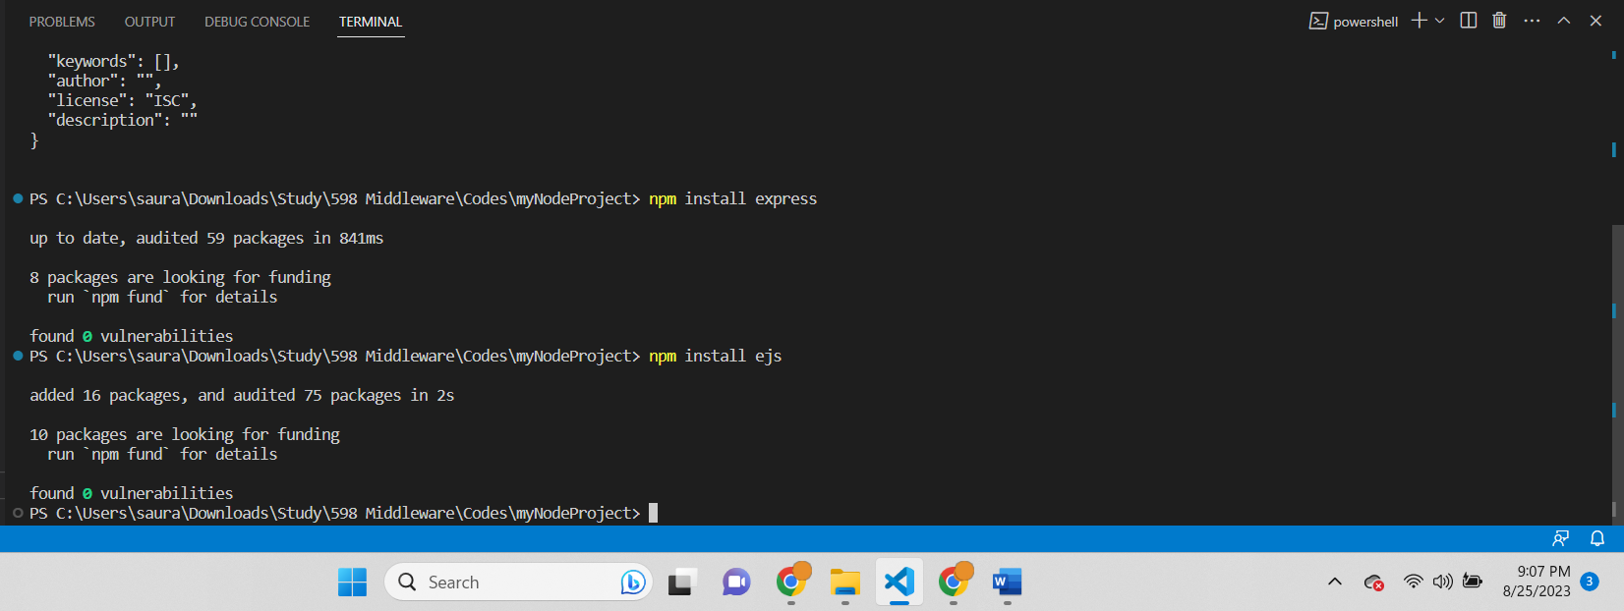

Express package and ejs package have been installed in the project.

PS C:\Users\saura\Downloads\Study\598 Middleware\Codes\myNodeProject> npm install express

up to date, audited 59 packages in 841ms

8 packages are looking for funding

run `npm fund` for details

found 0 vulnerabilities

PS C:\Users\saura\Downloads\Study\598 Middleware\Codes\myNodeProject> npm install ejs

added 16 packages, and audited 75 packages in 2s

10 packages are looking for funding

run `npm fund` for details

found 0 vulnerabilities

Project run successfully-

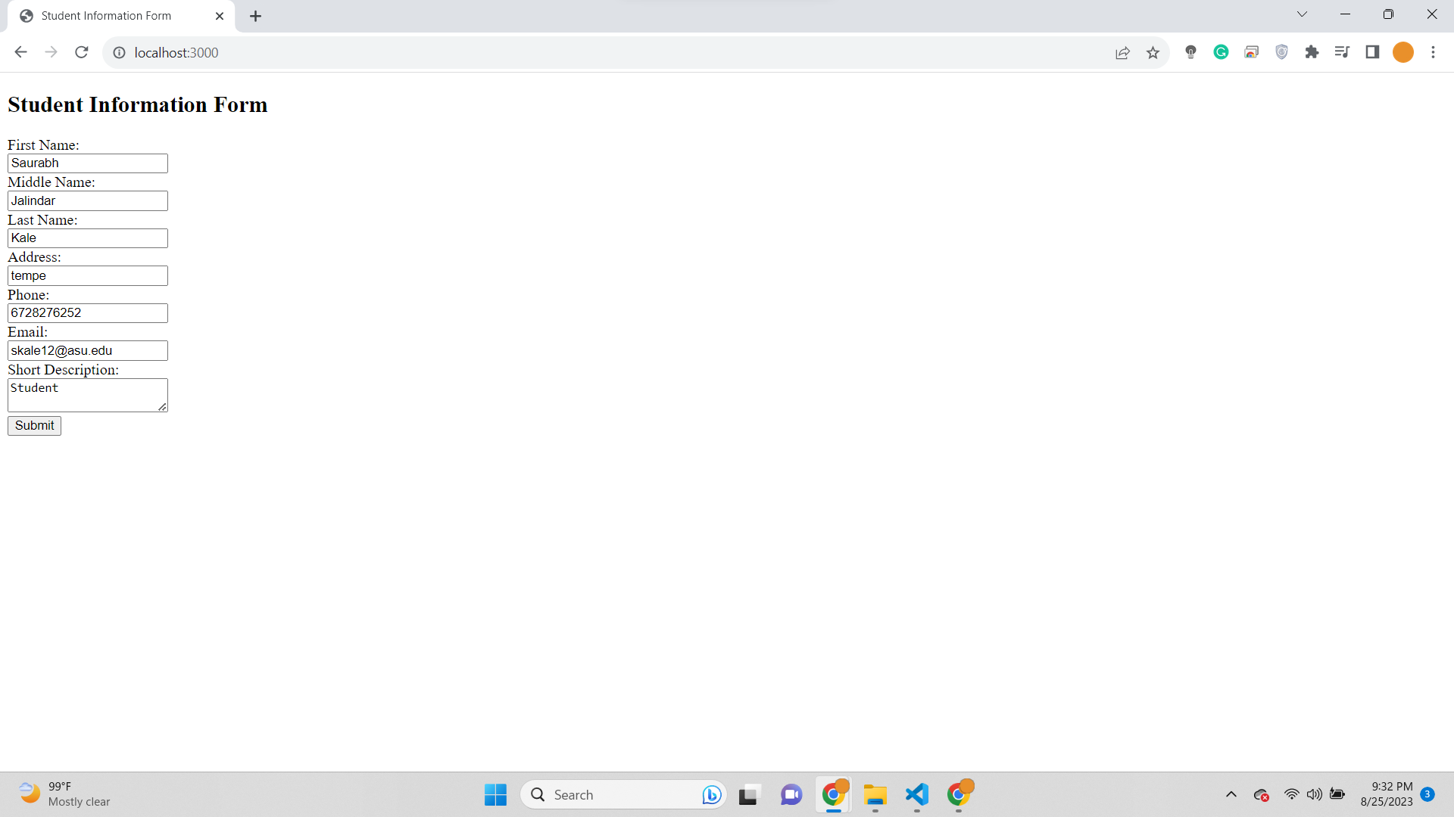

Output-

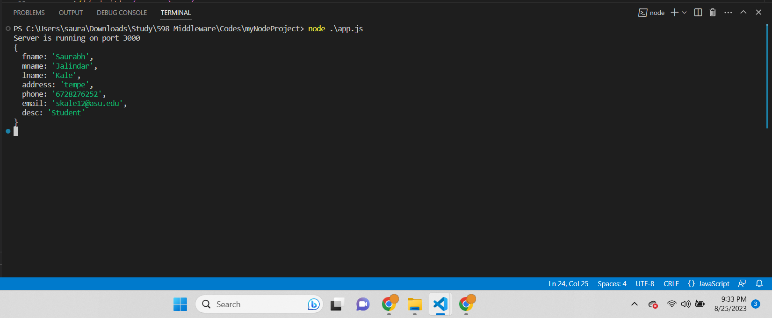

Output text-  
PS C:\Users\saura\Downloads\Study\598 Middleware\Codes\myNodeProject> node .\app.js

Server is running on port 3000

{

fname: 'Saurabh',

mname: 'Jalindar',

lname: 'Kale',

address: 'tempe',

phone: '6728276252',

email: 'skale12@asu.edu',

desc: 'Student'

}

Project Explorer-

